**ORGANIZATIONAL BEHAVIOUR PROJECT**

**STRESS MANAGEMENT**

**IN**

**PUBLIC VS CORPORATE EDUCATION SECTOR**

**Guidance By: Prof. A V S.Kamesh**

**Done By: Sri Megha Sarvani**

**AP23322130052**

**MBA-1st YEAR.**

**INTRODUCTION:**

To study the impact of stress in organizations which may affect the productivity of the employees.

Here I tried to compare the stress conditions of employees(teachers) working in 2 different organizations.

1.IGROW INTERNATIONAL SCHOOL, Narasaraopet.

2.KGBV (Kasturba Gandhi Balika Vidyalaya), Nakarikallu.

So I tried to bring out stress levels and working conditions in an international school and compare that with the government school run by central government.

**CONCEPT OF STRESS MANAGEMENT:**

Stress management refers to a wide spectrum of techniques and therapies that aim to control a person's levels of stress, especially chronic stress, to improve everyday functioning.

To reduce workplace stress, managers can monitor each employee's workload to ensure it is in line with their capabilities and resources.

Managers can also be clear and explicit about general expectations and long-term objectives to ensure there is no discrepancy between what the manager is looking for and what the employee is working toward.

Managers must keep culture in mind when approaching issues of workplace stress. They must quickly dismantle any negative workplace culture that arises, such as bullying or harassment.

**REVIEW OF RESEARCH ARTICLE OF STRESS MANAGEMENT:**

Review of research article includes:

* **Data collection using questionnaire**
* **Data cleaning and segregation**
* **Doing data analysis and interpretation**
* **Understanding data and presenting it visually**
* **Including KPI’s for better understanding**

**BRIEF ABOUT ORGANIZATIONS:**

**1.IGROW INTERNATIONAL SCHOOL**: IGROW International School also known as IGROW International School. The school was established in 2017. IGROW International School is a Co-Ed school affiliated to Central Board of Secondary Education (CBSE) . It is managed by Sri Lakshmi Ganapthi Educational Society.



The school provides international standards education along with extra-curricular activities like sports, arts and emphasis on all round development of the children.

2.**KGBV(KASTURBA GANDHI BALIKA VIDHYALAY)**:The KGBV NEKARIKALLU was established in 2005 and it is managed by the Department of Education. It is located in Rural area. It is located in NAKARIKALLU ,GUNTUR district of ANDHRA PRADESH. The school consists of Grades from 6 to 10. The school is for Girls, and it doesn't have an attached pre-primary section. Telugu is the medium of instructions in this school. This school is approachable by all-weather

road.

**METHODOLOGY:**

In this project I tried to bring out the stress factors for the teachers working in both government sector as well as private organizations.

I reached both schools and got data using manual questionnaire from the teachers working there.

Topics studied and Covered in this project are:

* Stress level at respective organizations.
* Cooperation between colleagues and superiors.
* Family support and Students cooperation.
* Factors causing stress.
* Analysing personality(Type-A or Type-B).
* Stress relieving activities.

**QUESTIONARE:**

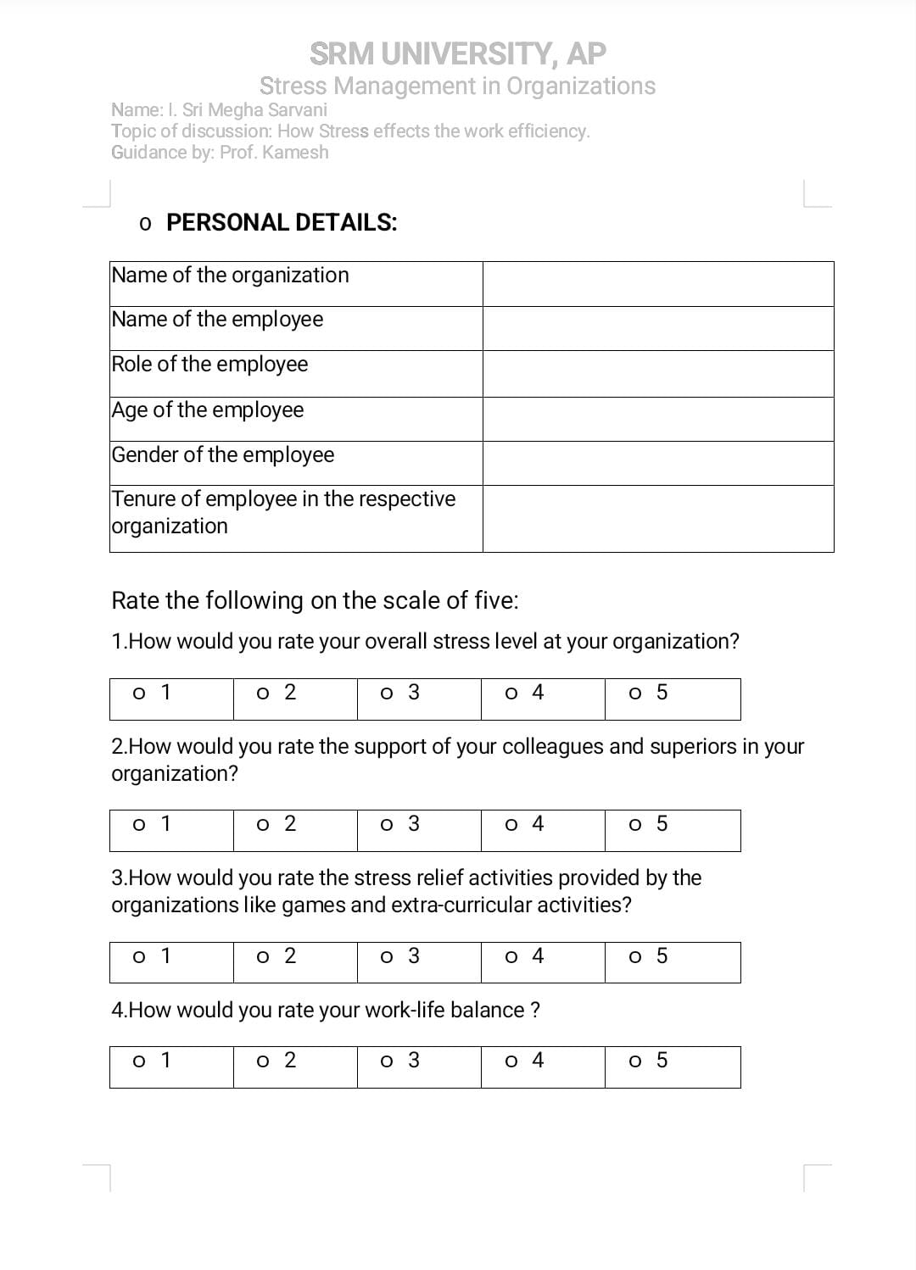

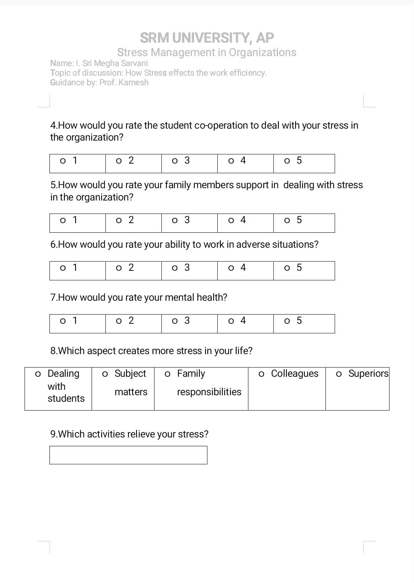

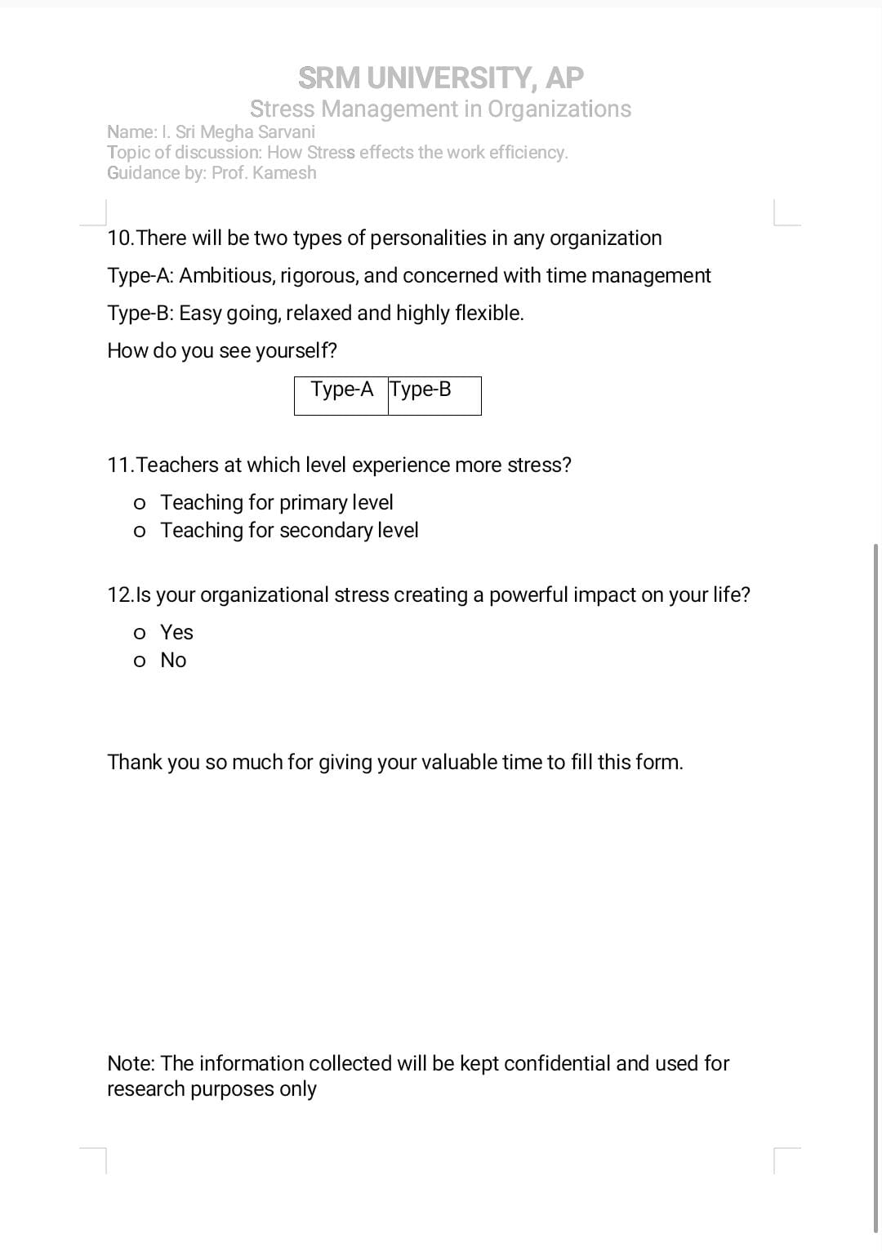

**COMPARITIVE ANALYSIS:**

**1.STRESS LEVEL COMPARISION:**

As we can see in the pie-diagram on left side we can infer that

Teachers working in the govt.school are facing more stress.

Teachers working in International school marked their stress level as 1-4 but 50% of govt.school teachers marked 3 and another 50% marked 4.

**Inference: Teachers/employees in public sector are having more stress.**

**2.SUPPORT FROM SUPERIORS AND COLLEAGUES:**

As we can see in the graph ,

The 81% of employees from I Grow rated that the support from superiors and colleagues as 4-5.

It shows the good relation between superiors and employees.

But 90% of employees from KGBV rated only 1-3 for the superiors and colleagues cooperation.

**Inference: Thus superiors and colleagues cooperation is good in IGROW when compared to KGBV**

**3.ASPECTS THAT CREATE STRESS IN LIFE:**

We can see that the employees from IGROW marked less reasons such as

* Dealing with students
* Family responsibilities
* Work life balance

KGBV employees expressed many reasons for their stress which includes

* Dissatisfaction from colleagues and superiors
* Subject matters
* Family responsibilities

**4.TYPES OF PERSONALITY:**

When analysed about personalities in both schools:

1.71% Type -B,29% Type-A in **IGROW**. 2.44% Type-B,56% TYPE-A IN **KGBV.**International school teachers are more focused on relaxed and easy-going methods of teaching.They focus more on quality of education.

**5.ACTIVITIES THAT RELIEVE STRESS IN ORGANIZATIONS:**

**.**

Here We can see that stress relief activities for the KGBV includes

* Drawing
* Music
* Yoga

Those are different for the employees working in IGROW

The pie-chart shows the distribution of Stress relief activities.

**6.IS ORGANIZATIONAL STRESS CREATING IMPACT IN YOUR LIFE?**

International school employees feel that their organizational stress is not creating powerful impact on their life.

Govt.school employees are feeling that their organizational stress is creating powerful impact in their life.

**7.SOME IMPORTANT KPI’S:**

**IGROW: KGBV:**

Average of stress level In

KGBV

3.575

Average of stress level in IGROW

**2.375**

Average ability to Work in Adverse situations

**3.125**

Average ability to Work in Adverse situations

2.75

Average Mental Health

3.645

Average Mental Health

3.4375

**CONCLUSION:**

* Teachers/employees in public sector are having more stress.
* Thus superiors and colleagues cooperation is good in IGROW when compared to KGBV**.**
* Average of stress level in IGROW is less than KGBV.
* Ability to work in adverse situation is more in IGROW when compared to KGBV.
* Stress relief activities are provided by the IGROW school for teachers whereas
* In Both Schools teachers are feeling that it is more stressful to teach for primary sections when compared to secondary sections.

**OTHER PARAMETERS WHICH CAN BE USED TO STUDY**

* Student-Cooperation:
* Family Responsibilities:
* Health Conditions Etc

**REFERENCES:**

* Data from questionnaire
* Organizational behaviour by Stephen.p.Robbins.
* Online sources: Google and chatgpt.
* Excel for Data Visualization.